WEEK1 PRACTICAL
QUERY1-
CREATE DATABASE IF NOT EXISTS bookkflow_dbb;
Output-

QUERY2-
USE bookkflow_dbb;
Output-

QUERY3-
CREATE TABLE books ( book_id INT AUTO_INCREMENT PRIMARY KEY, title VARCHAR(255) NOT NULL, isbn VARCHAR(13) NOT NULL UNIQUE, published_year INT, CONSTRAINT chk_published_year CHECK (published_year < 2027) );
Output-

QUERY4-
CREATE TABLE members ( member_id INT AUTO_INCREMENT PRIMARY KEY, full_name VARCHAR(100) NOT NULL, email VARCHAR(150) NOT NULL UNIQUE );
Output-

QUERY5-
DESCRIBE members;
Output-
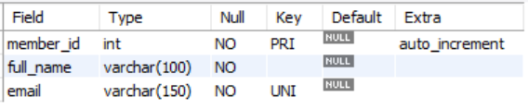

QUERY6-
INSERT INTO books (title, isbn, published_year) VALUES ('The Alchemist', '9780061122415', 1988), ('Clean Code', '9780132350884', 2008), ('Atomic Habits', '9780735211292', 2018);
Output-
QUERY7-
INSERT INTO members (full_name, email) VALUES ('Anil Kumar', 'anil.kumar@example.com'), ('Priya Sharma', 'priya.sharma@example.com'), ('Ravi Verma', 'ravi.verma@example.com');
Output-

======================================================================
CONSTRAINT TESTS (MUST FAIL)
TEST1-Duplicate ISBN (UNIQUE violation)
INSERT INTO books (title, isbn, published_year) VALUES ('Fake Copy', '9780061122415', 2000);
Output-
TEST2-NULL title (NOT NULL violation)
INSERT INTO books (title, isbn, published_year) VALUES (NULL, '9999999999999', 2010);
Output-

TEST3-Future publication year (CHECK violation)
INSERT INTO books (title, isbn, published_year) VALUES ('Time Traveler', '8888888888888', 2030);
Output-

TEST4-Duplicate Email(UNIQUE violation)
INSERT INTO members (full_name, email)
VALUES ('Anil Clone', 'anil.kumar@example.com');
Output-

